Client/Server programming using TCP

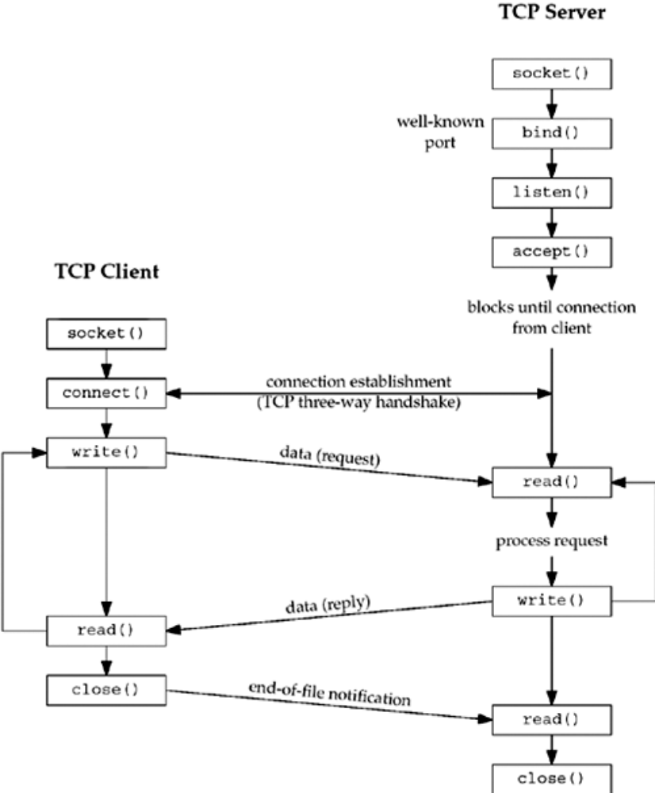

Instructions-1 You have to always include at least these header files in most of the client/ server programs

#include<sys/types.h>

#include<sys/socket.h>

#include<netinet/in.h>

#include<stdlib.h>

#include<netdb.h>

#include<stdio.h>

Instructions-2 See the code for the file sum.h

struct args {

long arg1;

long arg2;

};

struct result {

long sum;

};

Instruction-3 See the code for client’s site and understand.

#include<sys/types.h>

#include<sys/socket.h>

#include<netinet/in.h>

#include<stdlib.h>

#include<netdb.h>

#include<stdio.h>

#define maxline 4096

#include "sum.h"

void str_cli(FILE *,int);

int

main(int argc,char **argv)

{

int sockfd,n,cn;

char recvline[maxline+1];

struct sockaddr_in servaddr;

if(argc !=2)

printf("usage: a.out <IPaddress>");

if((sockfd=socket(AF_INET,SOCK_STREAM,0))<0)

printf("socket error");

bzero(&servaddr,sizeof(servaddr));

servaddr.sin_family=AF_INET;

servaddr.sin_port=htons(4500);

if(inet_pton(AF_INET,argv[1],&servaddr.sin_addr)<=0)

printf("inet_pton error for %s", argv[1]);

cn=connect(sockfd,(struct sockaddr*)&servaddr,sizeof(servaddr));

if(cn < 0)

{

printf("\nconnect error\n");

exit(0);

}

else

printf("\nconnection has been estabished");

str_cli(stdin,sockfd);

exit(0);

}

/* code for str_cli() function */

void str_cli(FILE *fp,int sockfd)

{

char sendline[maxline],recvline[maxline];

struct args args;

struct result result;

while(fgets(sendline,maxline,fp)!=NULL)

{

if(sscanf(sendline,"%ld %ld", &args.arg1, &args.arg2) !=2)

{

printf("\ninvlid input:%S\n",sendline);

continue;

}

printf("the values are %ld%ld\n",args.arg1,args.arg2);

write(sockfd,&args,sizeof(args));

if(read(sockfd,&result,sizeof(result))==0)

printf("error");

printf("socket desc read is %d\n",&sockfd);

printf("%ld\n",result.sum);

}

}

Instruction-4 See the code for server’s site and understand

#include<sys/types.h>

#include<sys/socket.h>

#include<netinet/in.h>

#include<stdlib.h>

#include<netdb.h>

#include<stdio.h>

#include<time.h>

#define maxline 4096

#define LISTENQ 5

#include "sum.h"

void str_echo(int);

int main(int argc,char *argv)

{

int listenfd,connfd,bd;

pid_t childpid;

struct sockaddr_in servaddr;

char buff[maxline];

time_t ticks;

if(( listenfd=socket(AF_INET,SOCK_STREAM,0))<0)

{

printf("error");

}

bzero(&servaddr,sizeof(servaddr));

servaddr.sin_family=AF_INET;

servaddr.sin_addr.s_addr=htonl(INADDR_ANY);

servaddr.sin_port=htons(4500);

if((bd=bind(listenfd,(struct sockaddr*)&servaddr,sizeof(servaddr)))<0)

{

printf("\nbind error");

exit(0);

}

listen(listenfd,LISTENQ);

for(;;){

connfd=accept(listenfd,(struct sockaddr*)NULL,NULL);

if((childpid=fork())==0) {

close(listenfd);

str_echo(connfd);

exit(0);

}

close(connfd);

}

}

/* code for str_echo function */

void str_echo(int sockfd)

{

ssize_t n;

struct args args;

struct result result;

char line[maxline];

for(;;) {

n= read(sockfd,&args,sizeof(args));

if(n==0)

return;

printf("the server are %ld%ld\n",args.arg1,args.arg2);

result.sum=args.arg1 + args.arg2;

// printf("the value returned by server is %ld\n ",result.sum);

// break;

//result.sum = args.arg1 - args.arg2;

//break;

write(sockfd,&result,sizeof(result));

}

}

